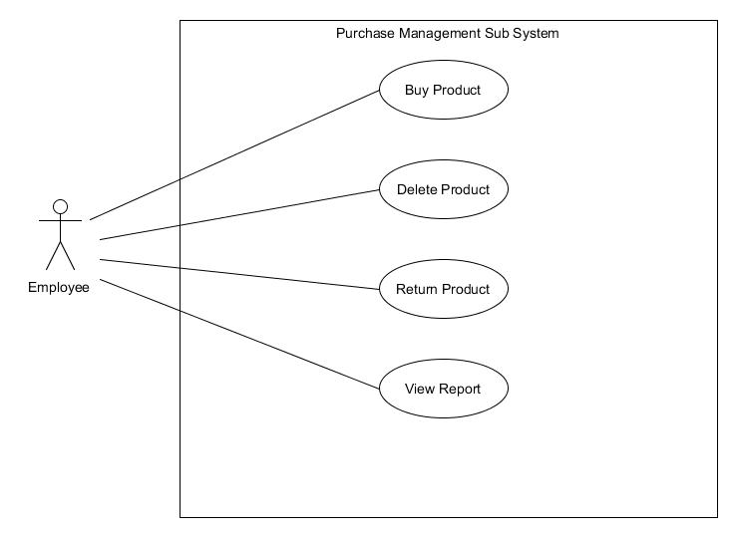

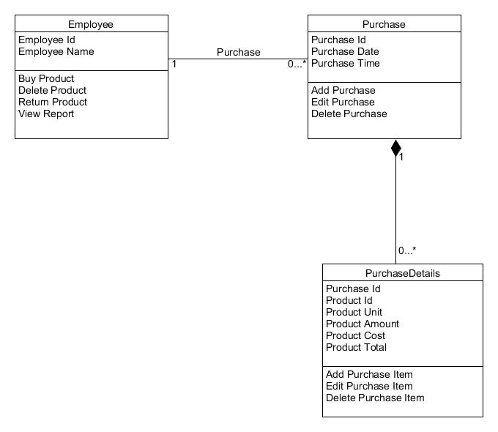

**Sequence Diagram demonstrating operation “Add product”**

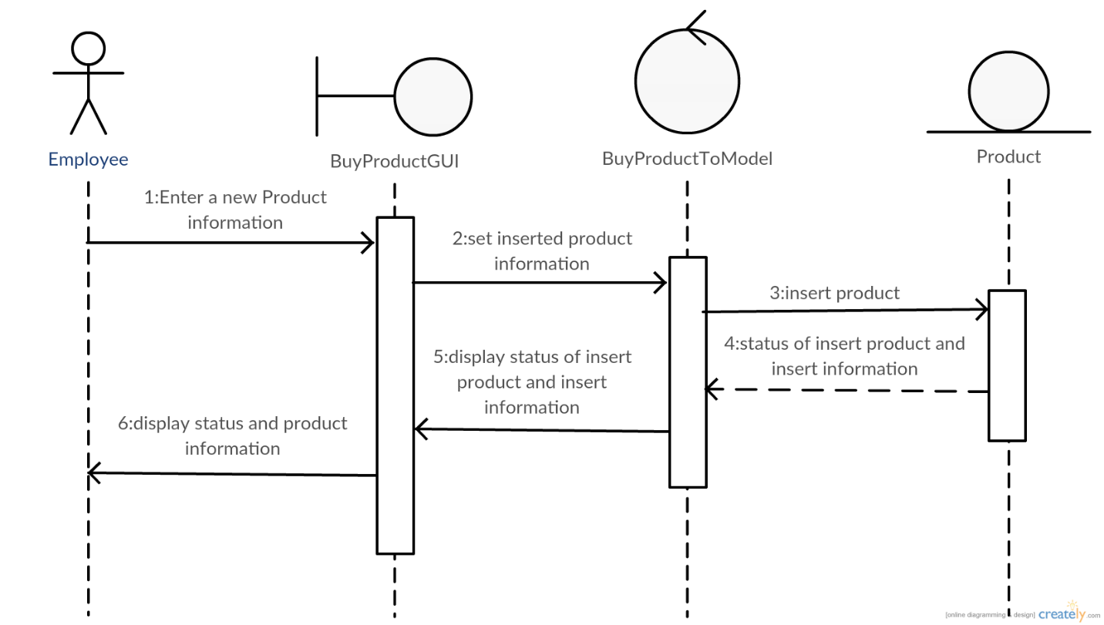

**Sequence Diagram demonstrating operation “Delete product”**

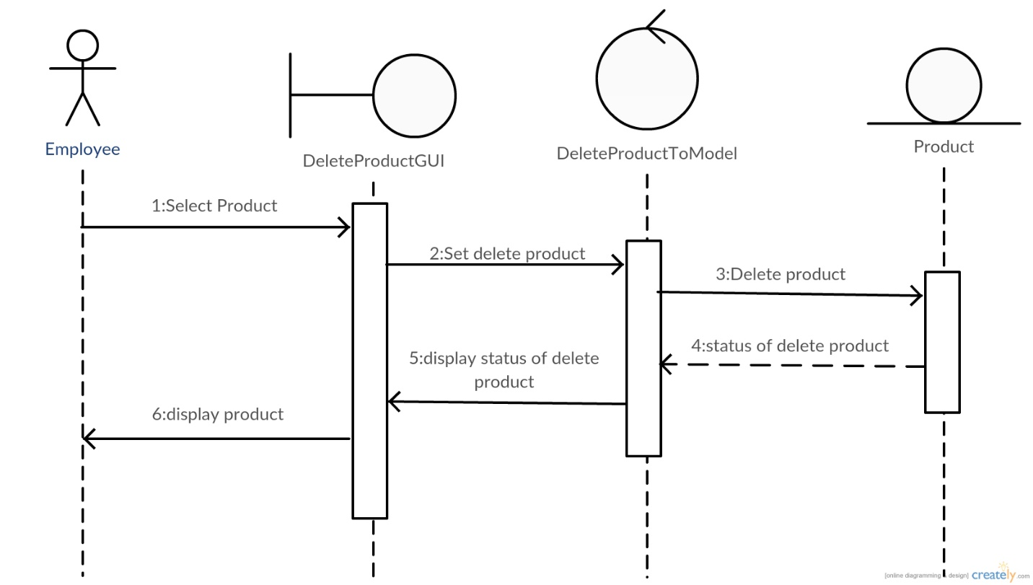

**Sequence Diagram demonstrating operation “Return product”**

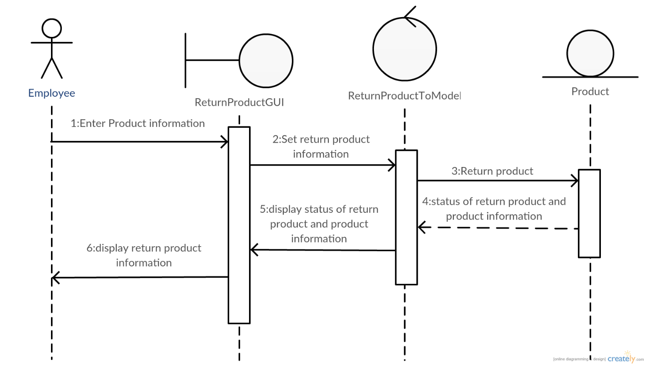

**Sequence Diagram demonstrating operation “View Report”**

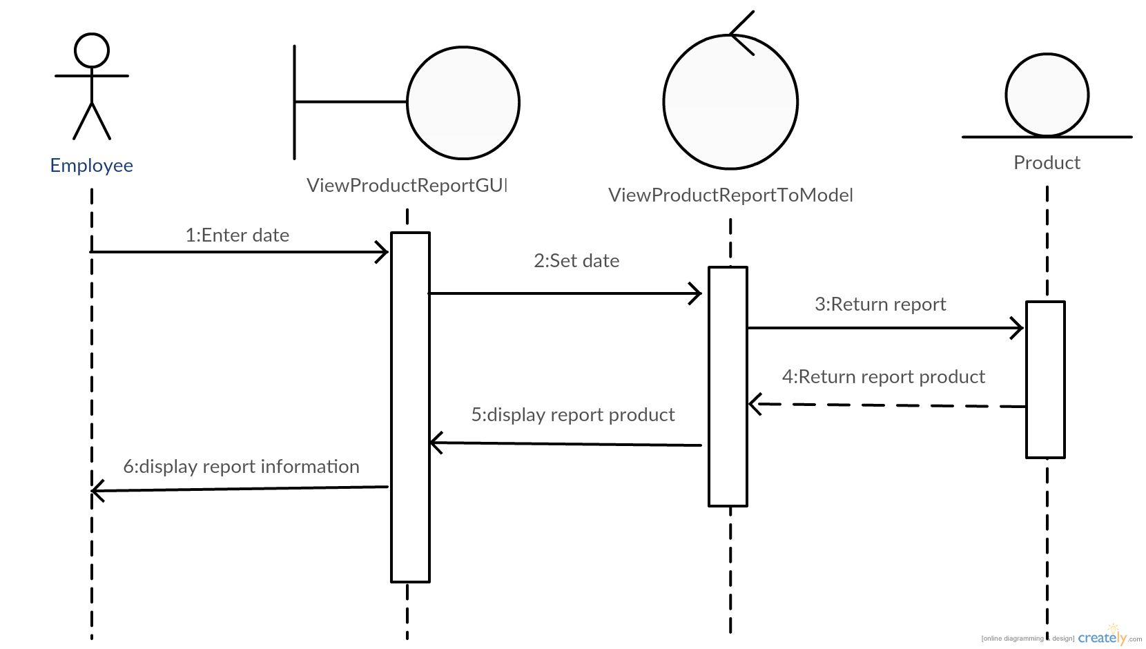

**Model-View-Controller (MVC) Model “Add Product”**

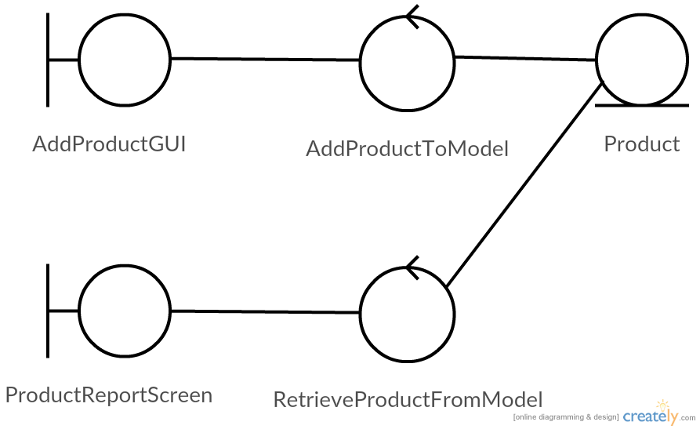

**Model-View-Controller (MVC) Model “Delete Product”**

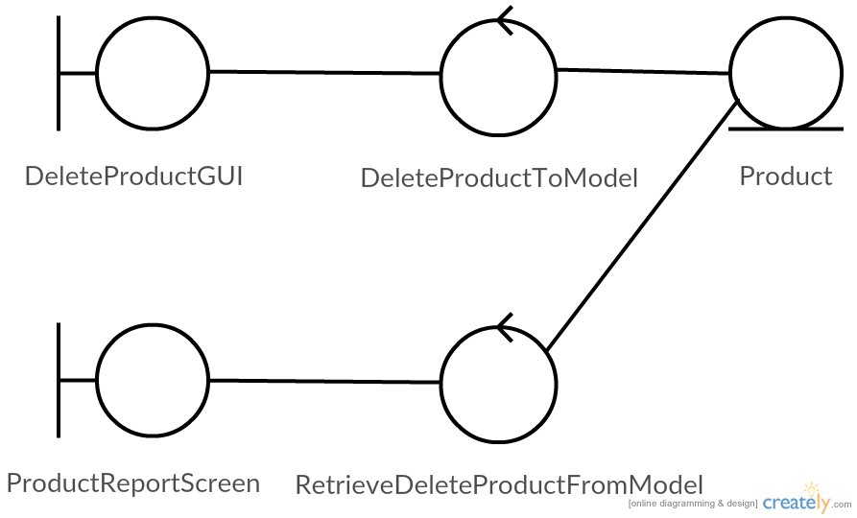

**Model-View-Controller (MVC) Model “Return Product”**

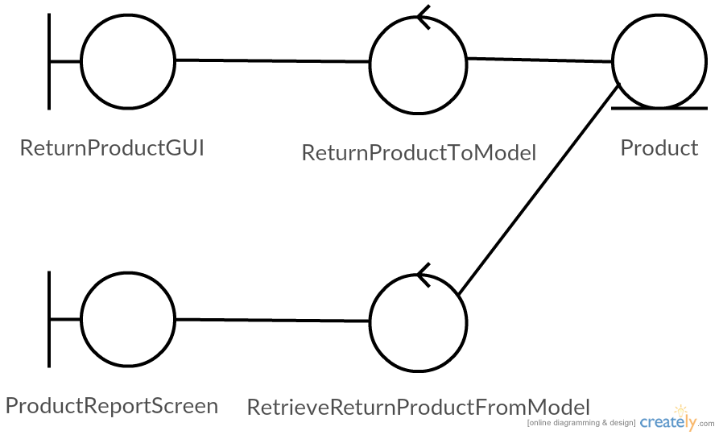

**Model-View-Controller (MVC) Model “View Report”**

